AI-Assisted Code Lab Test-1

**1Question**:Write a comment prompt with 2 to 3examples to generate a python function that checks whether a string is palindrome.

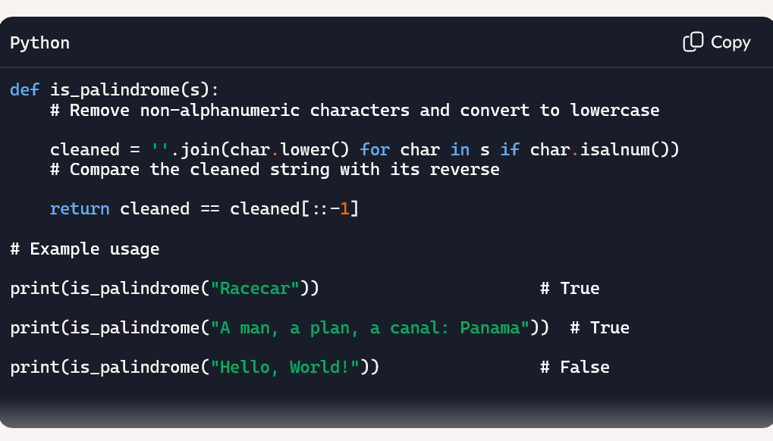

Explanation:

* char.isalnum() filters out punctuation and spaces.
* char.lower() ensures case-insensitive comparison.
* cleaned[::-1] reverses the string.

**2Question**: Generate a python program that finds the largest and smallest numbers in a user provided list,then explain how this code works.

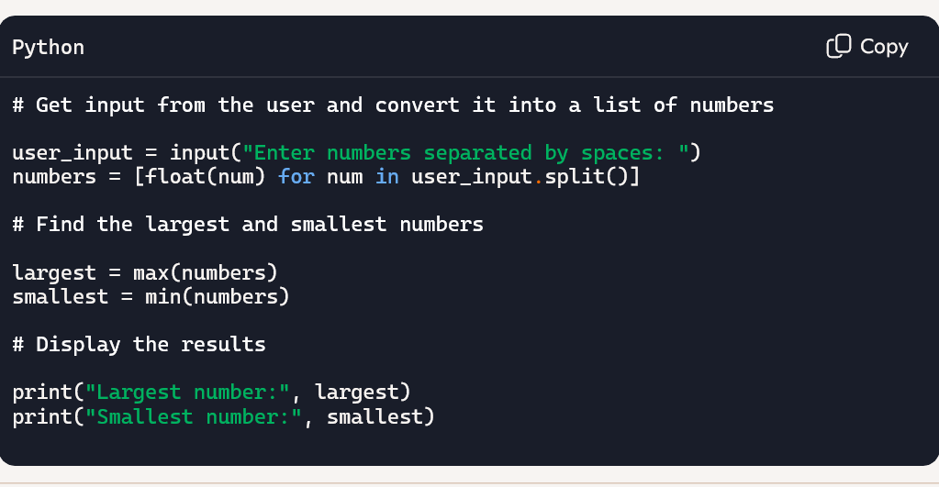

Explanation:

1. Prompts the user to enter numbers like: 10 25 3.5 42

2. The input is captured as a single string.

3. .split() breaks the string into a list of substrings based on spaces.

4.float(num) converts each substring into a number (supports decimals too).

5.The result is a list like [10.0, 25.0, 3.5, 42.0, -7.0].

6.max() finds the highest value in the list.

7.min() finds the lowest value.